MediInsights: Patient Inflow & Treatment Analysis

1.Introduction:
Hospitals generate large volumes of patient data daily, including admissions, discharges, treatment costs, and departmental performance. Analyzing this data is essential to monitor patient inflow, evaluate treatment performance, and manage hospital resources efficiently.
This project focuses on analyzing inpatient and outpatient trends, departmental performance, doctor-wise patient count, and treatment cost distribution to support better healthcare management decisions.

2.Problem Statement
The hospital lacks a centralized system to monitor patient inflow and treatment performance across departments and doctors.
Without structured analysis:
- Patient admission trends are unclear.
- Inpatient and outpatient distribution is not properly monitored.
- Treatment costs may contain inconsistencies.
- Department and doctor performance cannot be evaluated effectively.
An interactive dashboard is required to analyze patient flow and treatment cost patterns.

3.Dataset Description
The dataset contains patient-level hospital records. Each row represents one patient’s visit or admission record.
The dataset includes the following key columns:
- Patient ID – Unique identifier assigned to each patient.
- Admission Date – Date when the patient was admitted to the hospital.
- Discharge Date – Date when the patient was discharged.
- Department – Department where treatment was provided (e.g., Cardiology, Orthopedics, Neurology, General).
- Doctor – Name of the doctor responsible for treatment.
- Treatment Cost – Total cost incurred for the patient’s treatment.
- Patient Type (In/Out) – Indicates whether the patient was admitted (Inpatient) or treated without admission (Outpatient).
This dataset enables analysis of patient inflow trends, department performance, and cost distribution.

4.Tools Used
1. Google Sheets
Used for initial data gathering, basic inspection, and quick validation of the dataset before importing it into Python. It helped in reviewing column structure, identifying missing values, and performing preliminary checks.
2. Python
Used as the primary programming language for data processing and analysis.
3. Pandas
Used for data cleaning, transformation, and manipulation, including handling missing values, correcting inconsistent data, filtering records, and preparing datasets for analysis.
4. NumPy
Used for numerical operations and calculations, such as performing mathematical computations, aggregations.
5. Power BI
Used to build an interactive dashboard with KPIs, charts, slicers, and DAX measures to analyze patient inflow and treatment performance.

5.Data cleaning and Preprocessing
Python libraries like Pandas and NumPy were used to perform the data cleaning and preprocessing process and guarantee data quality and readiness to analysis.
- First, the CSV file was imported using Pandas to inspect structure and data types.
- Then, the data was initially investigated with the help of Pandas functions such as info or describe in order to capture the data structure, the type of data, and the existence of missing data.
- The Admission Date and Discharge Date columns were converted into datetime format to enable time-based analysis and length-of-stay calculation.
- For outpatient records, since outpatients are treated and discharged on the same day, the Admission Date was set equal to the Discharge Date to maintain logical consistency.
- The minimum inpatient treatment cost was identified to establish a baseline cost reference.
- Invalid outpatient cost records were managed by identifying cases where Outpatient Cost was lower than the minimum inpatient cost threshold. These inconsistencies were corrected to ensure realistic cost values.
- To simplify KPI calculations in Power BI, two additional columns were created:
a)One column to indicate Inpatient status
b)One column to indicate Outpatient status
These binary indicator columns helped calculate inpatient and outpatient counts efficiently using aggregation functions.
These preprocessing steps ensured accurate patient classification, cost validation, and consistent date handling.

6.Power BI Dashboard
After preprocessing, the dataset was imported into Power BI to develop the Hospital Analytics Dashboard, which provides insights into patient inflow, departmental performance, and treatment cost analysis
KPI Cards
The top section of the dashboard displays key performance indicators:
- Average Length of Stay (Inpatient) – Shows the average number of days admitted patients stay in the hospital.
- Total Outpatients – Displays the total number of outpatient visits.
- Total Inpatients – Indicates the total number of admitted patients.
- Total Treatment Cost (3M) – Represents the overall revenue generated from treatments.
These KPIs provide a quick summary of hospital performance and patient activity.

Visualizations Included
1. Monthly Patient Admission Trend (Line Chart)
This chart displays inpatient and outpatient trends over time. It helps identify seasonal variations, patient inflow patterns, and peak admission periods.
2. Patient Count by Department (Stacked Column Chart)
Compares inpatient and outpatient distribution across different departments, enabling performance evaluation and workload analysis at the departmental level.
3. Patient Count by Doctor (Bar Chart)
Shows doctor-wise patient count, helping assess workload distribution and identify high-demand medical professionals.
4. Inpatient vs Outpatient (Donut Chart)
Illustrates the proportion of inpatient and outpatient cases, providing a quick comparison of patient types.
5. Treatment Cost Distribution by Patient Type (Pie Chart)
Displays revenue contribution from inpatient and outpatient treatments, helping analyze financial performance.
6. Summary Table
Provides detailed patient-level information including:
- Patient ID
- Department
- Doctor
- Patient Type
- Admission Date
This allows deeper drill-down analysis at the individual patient level.
Filters and Slicers
Interactive slicers such as Patient Type, Patient ID, Department, Admission Date, and Discharge Date enable users to dynamically filter data and analyze specific segments.

DAX Measures Used
DAX (Data Analysis Expressions) was used in Power BI to calculate key hospital performance metrics and support interactive analysis.
- Total Inpatients – Calculates the total number of admitted patients using the inpatient indicator column.
- Total Outpatients – Calculates the total number of outpatient visits using the outpatient indicator column.
- Total Treatment Cost – Computes the overall revenue generated from patient treatments by summing the treatment cost column.
- Average Length of Stay (Inpatient) – Calculates the average number of days admitted patients stayed in the hospital, based on the difference between Admission Date and Discharge Date.
These measures enable dynamic KPI calculation and help monitor patient inflow, hospital workload, and financial performance effectively.

7.Conclusion
The Hospital Analytics Dashboard provides a structured and data-driven approach to analyze patient inflow and treatment performance.
By validating cost inconsistencies, standardizing admission records, and categorizing patient types, the dashboard ensures reliable healthcare insights. It enables hospital management to monitor departmental performance, evaluate doctor workload, track patient trends, and analyze revenue distribution.
Overall, this project demonstrates how data analytics and Power BI can support better decision-making in healthcare management and improve operational efficiency.

8.Dashboard Photos
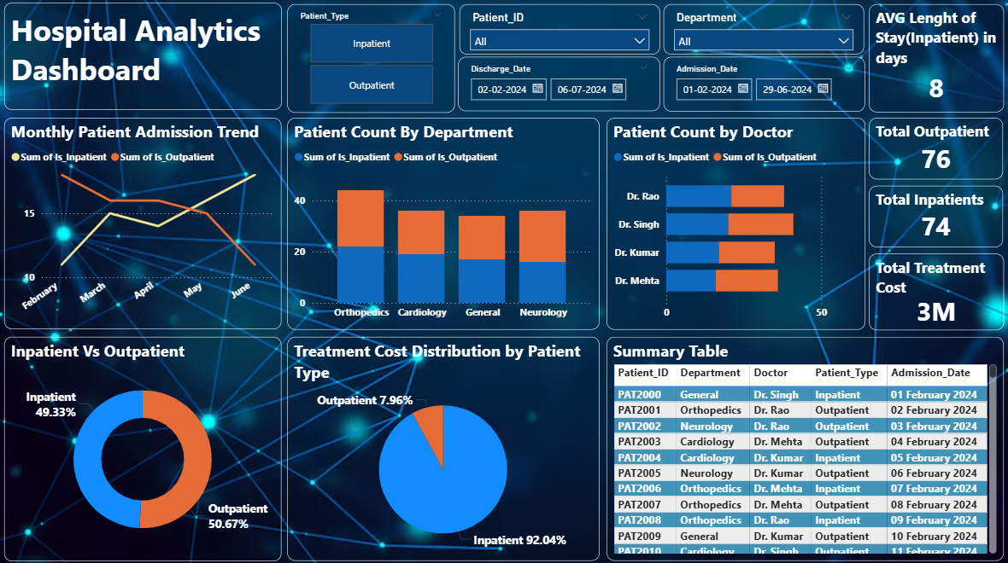
Submitted By:Dnyaneshwari Pawar

